**MINI ASSIGNMENT 1 DOCUMENTATION**

**My Approach to the Assignment:**

**I tried a lot of processes after watching the youtube videos but the given XML files were not loading.**

**So I tried this different approach suggested by the Track Helpers about writing codes to segregate the file,**

**So then I downloaded PYCHARM my favourite Python IDE to write codes.**

**Even After A lot of tries with parsing and Commands I could Not fetch the N=required number Of Rows**

**I Even Tried With SnowSQL and I was getting Errors at AWS Data Load.**

**So I moved On the manual approach of trimming the data and selected N rows to make the file small.**

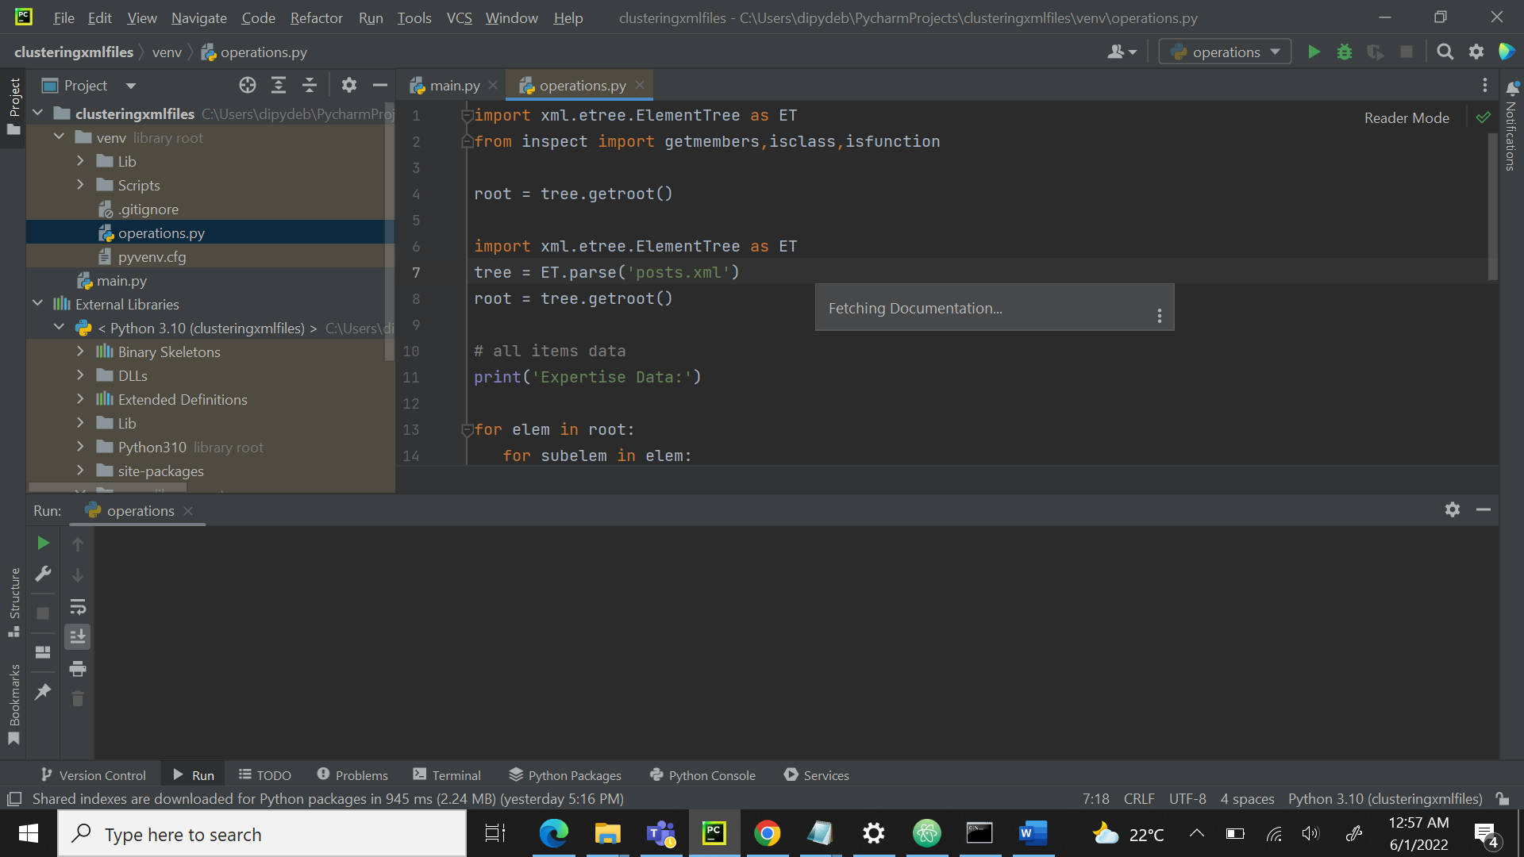

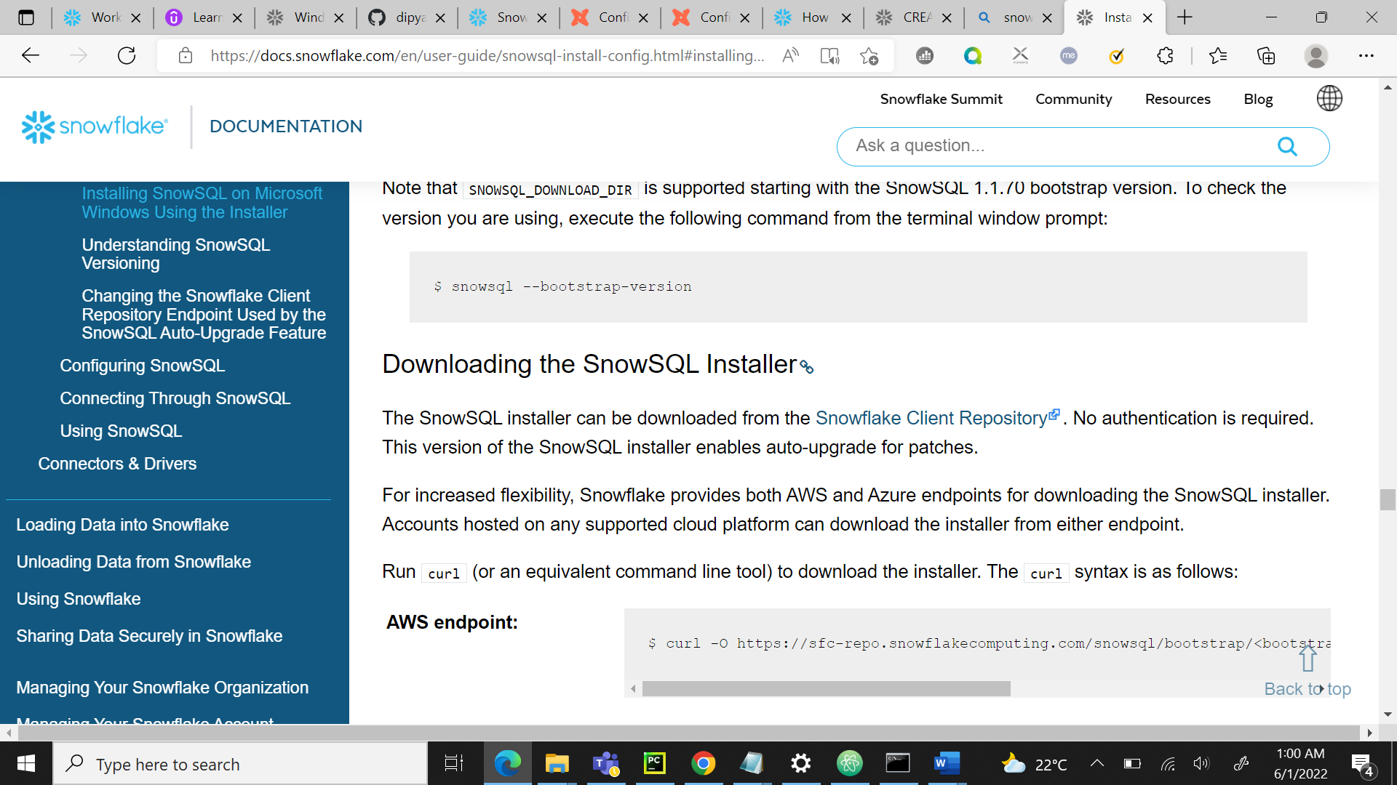

**I have tried with the documentation:** [Installing SnowSQL — Snowflake Documentation](https://docs.snowflake.com/en/user-guide/snowsql-install-config.html#installing-snowsql-on-microsoft-windows-using-the-installer)

But I removed everything from that and deleted as It was giving an error.

I was not able to write the queries I even tried a different method but it was of no use.

I also tried to create the table manually but the data would not load.

**ERRORS WHILE LOADING DATA IN TABULAR FORMAT:**

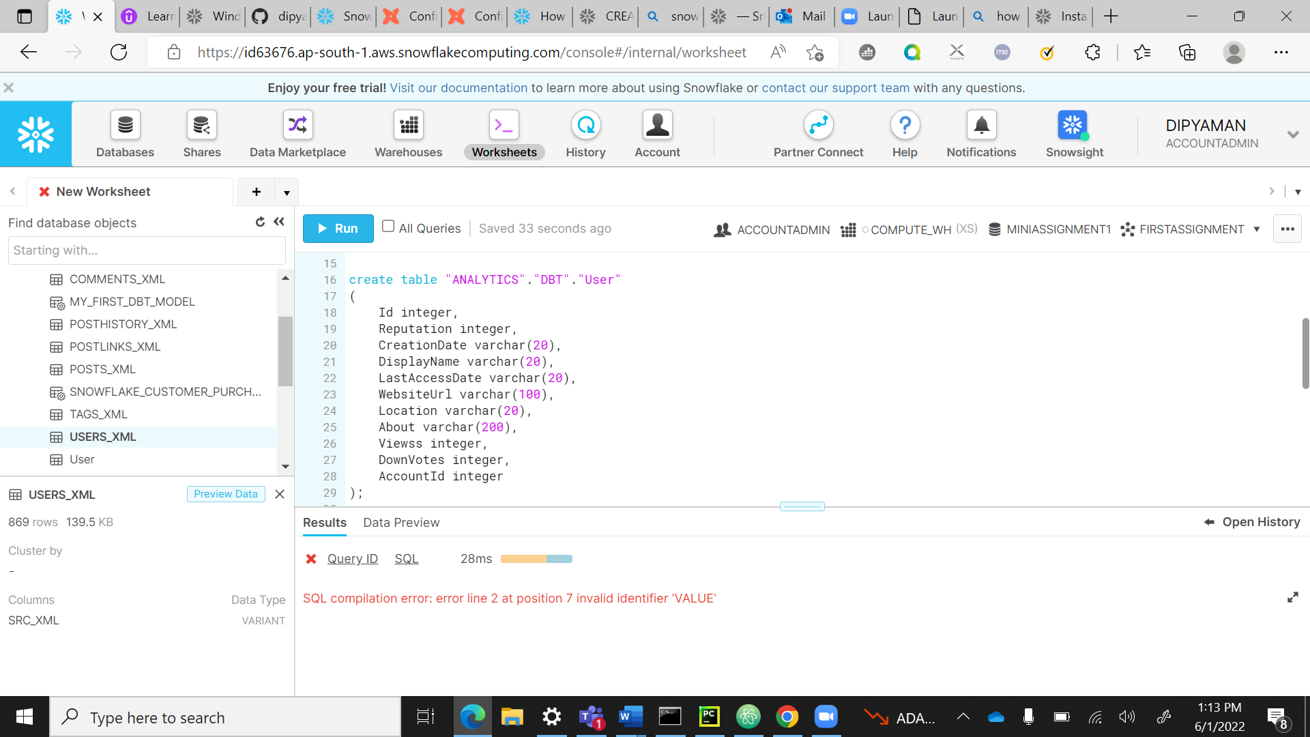

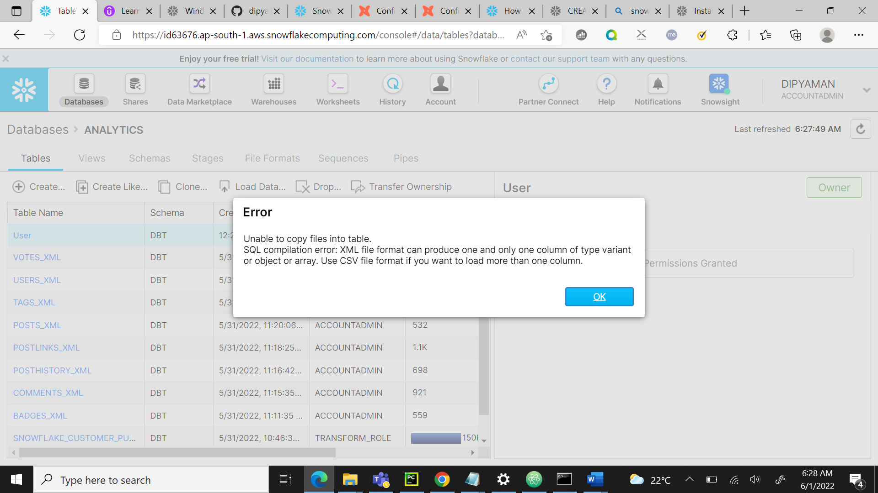

OUTPUT:

ABLE TO LOAD THE DATA MANUALLY:

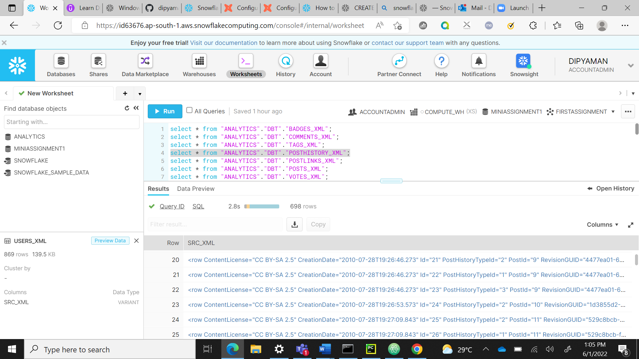

ERRORS:

